Trouble Logging in?

If you know your username and password and get an “Invalid Username or Password” error, either scan the following QR code, or go to the previous page and click on PWCS Password Self-Service page to reset your password.
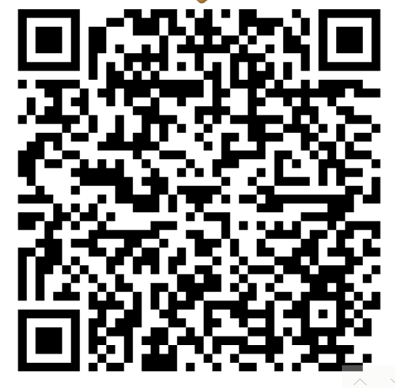

Getting a strange message about a “domain”? First, try pushing the F11 button on the top row of your laptop. Then hold down these three buttons at the same time: CTRL ALT DELETE. In the bottom right hand corner of the screen will be a circle with a line coming out the top of it. Click on that circle, and click RESTART. Then, try to login again.

If you still get the same “domain” error, you will have to take the device to one of our “Hot Spots” in the county, listed on the previous page. Once arriving at a Hot Spot, log in with your device.

